**Open Source Coding (Introduction)**

**OPSC6311**

**Lethukuthula Kumalo**

**ST10392005**

**DUE DATE: 02 APRIL 2025**

**PART 1: RESEARCH**



App 1: Fireflylll

Firefly III is an open-source, self-hosted finance manager offering privacy and control over financial data, unlike mainstream apps that rely on cloud services. This document explores its features and how it can be used in a Kotlin-based budgeting app.

**Overview of the app**

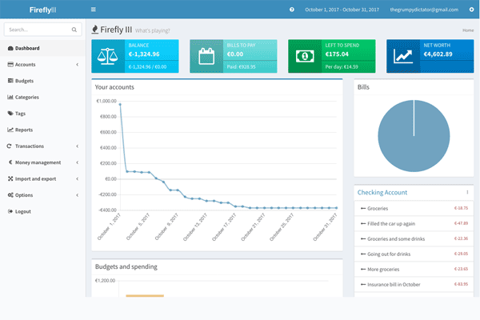

Account Summary and Budgeting

The screenshot displays the user's account summary and budgeting details, including account balance, bills, available funds, and net worth. A graph shows financial trends, a pie chart visualizes expenses, and a right-hand panel lists recent transactions for easy tracking.

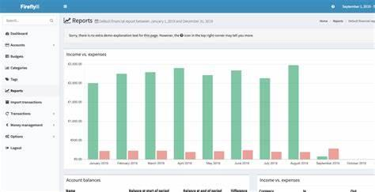

Reports and Analytics

The screenshot highlights the reports and analytics section, featuring a bar chart that visualizes income and expenses over time. It helps users analyze spending habits and track financial progress, with a consistent sidebar menu for easy navigation.

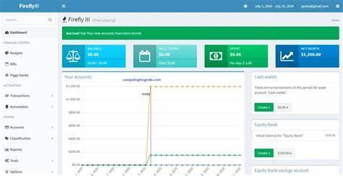

Dashboard Overview

The screenshot shows the Firefly III dashboard, offering an overview of account balances, budgets, and spending insights. It features a left-side navigation menu for accessing transactions, reports, and settings, with a central chart visualizing financial trends.

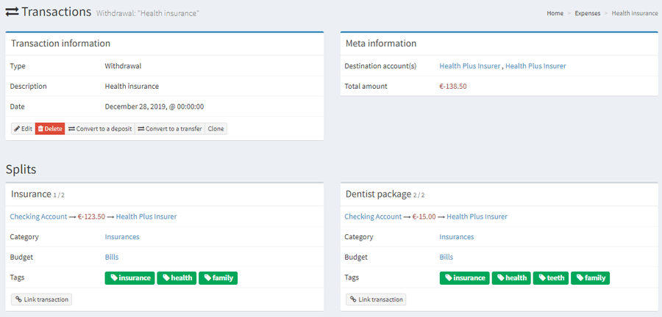

Transactions

The system offers detailed transaction views with amount, date, and category, helping users track spending and recurring expenses. It supports expense splitting, displays merchant details, and allows filtering by categories. Color-coded labels and a search function enhance financial insights and transaction tracking.

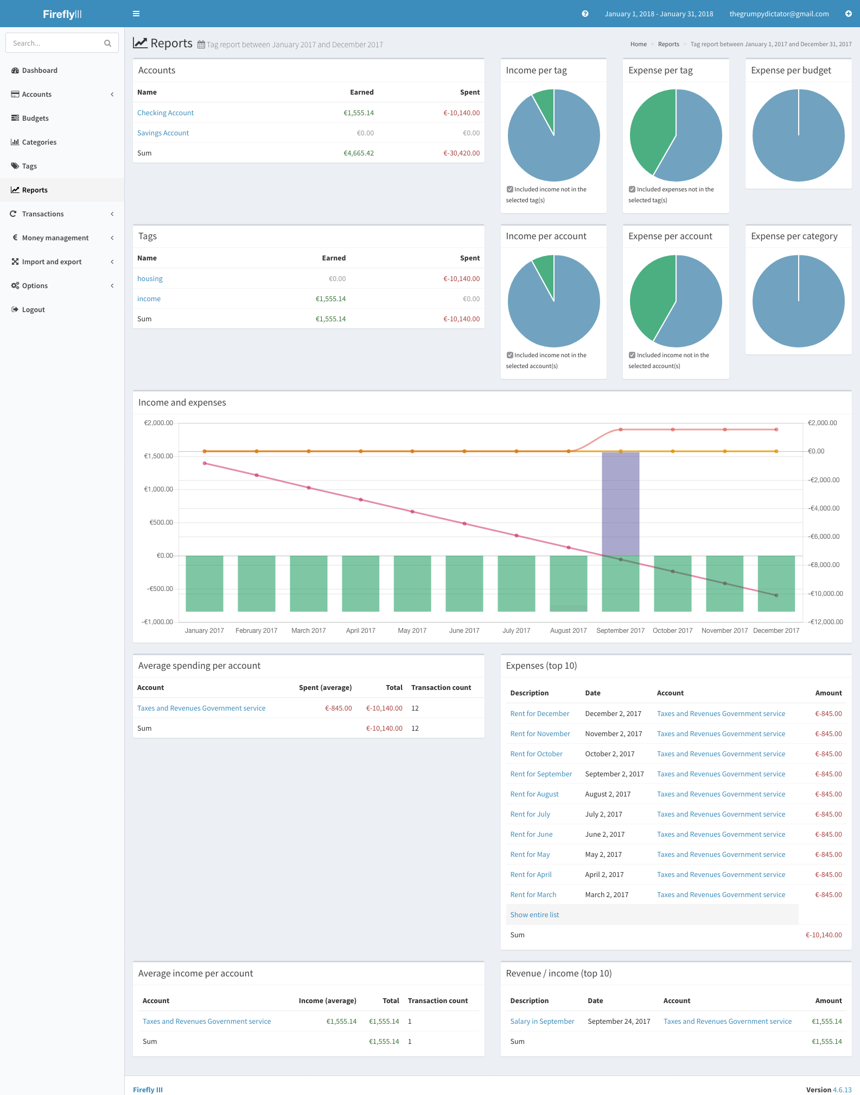

The Reports Section in Firefly III is a powerful feature that provides users with visual insights into their financial data. This section helps users track their financial health over time by displaying income, expenses, net worth, and budget trends through various graphs and charts.

**Strengths and Weaknesses**

Strengths

* Self-Hosted & Open Source – Users have full control over their financial data, unlike cloud-based services.
* Strong Data Privacy – Since it's self–hosted, data is not stored on third-party servers.
* Highly Customizable – Advanced users can modify the platform to fit their needs.
* Multi-Currency Support – Ideal for users handling finances in multiple currencies.
* Powerful Reporting Tools – Provides deep insights into financial trends and habits.
* Automation via Rules – Saves time by automatically categorizing and cleaning transactions.
* Active Community Support – Regular updates and contributions from developers worldwide.

### Weaknesses

* Complex Setup – Requires manual installation on a server, which may be challenging for non-technical users.
* No Official Mobile App – Users need to rely on third-party apps or web access.
* Limited UI Design – The web interface, while functional, is not as visually polished as mainstream budgeting apps.
* Dependency on Self-Hosting – Users must maintain their own server, which includes managing security updates and backups.
* Steeper Learning Curve – The advanced features (like double-entry bookkeeping) may overwhelm casual users.

**Key Features of Firefly III**

1. Full Transaction Management: Double-entry bookkeeping, multi-currency support, and efficient expense categorization.
2. Data Importing Capabilities: Seamless migration from other platforms, including CSV files and bank statements, reducing manual entry.
3. Advanced Rule Engine: Automates transaction categorization and cleans bank statements/CSV files.
4. Budgeting, Categories, and Tags: Organize finances with multi-currency budgeting and track specific spending habits.
5. Informative Reports & Analytics: Generates detailed financial reports, audits accounts, and offers budget comparisons with graphical data representations.
6. JSON REST API: Allows integration with mobile/web apps for dynamic transaction management and financial chart access.

App 2: Count About

An easy-to-use tool for managing personal or small business finances, designed to track expenses and simplify budgeting. It seamlessly imports data from platforms like Mint and Quicken, making it perfect for users transitioning from other tools.

**Overview of the app**

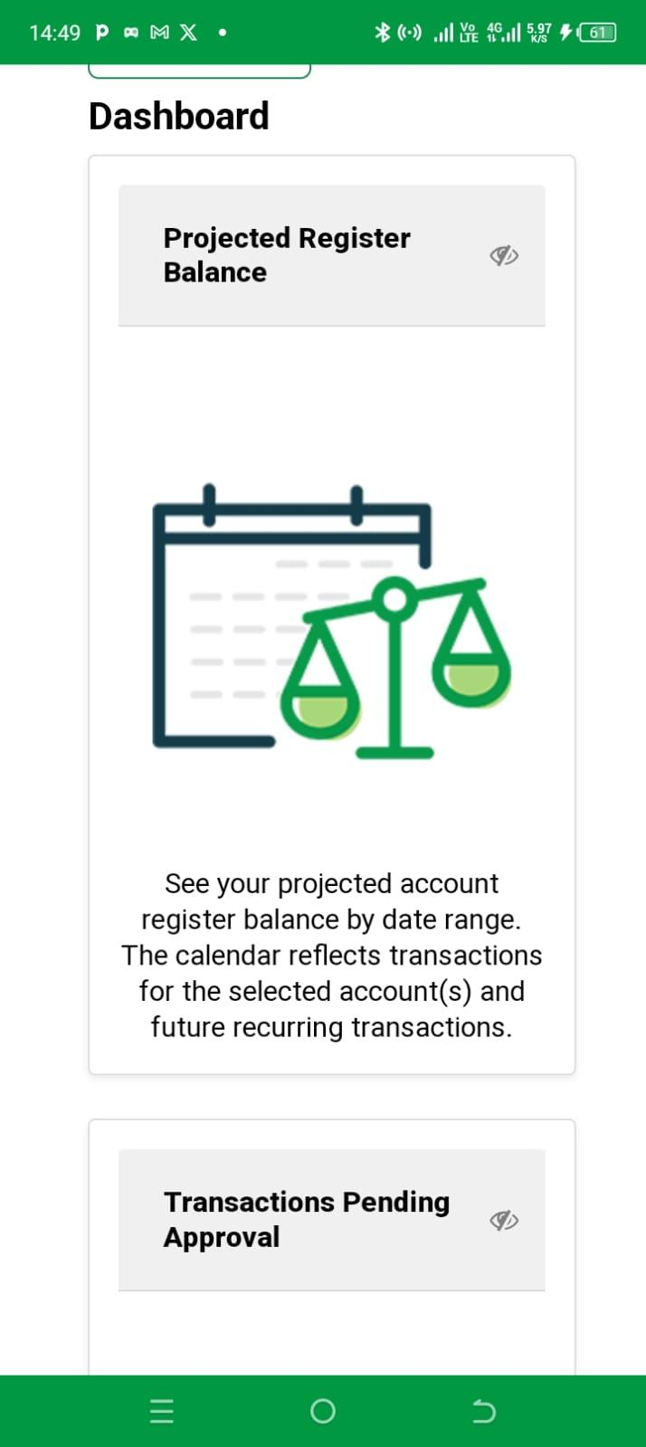

### Dashboard

Displays a high-level summary of finances, including account balances, budget progress, and recent transactions, often with visual charts to track income and expenses.

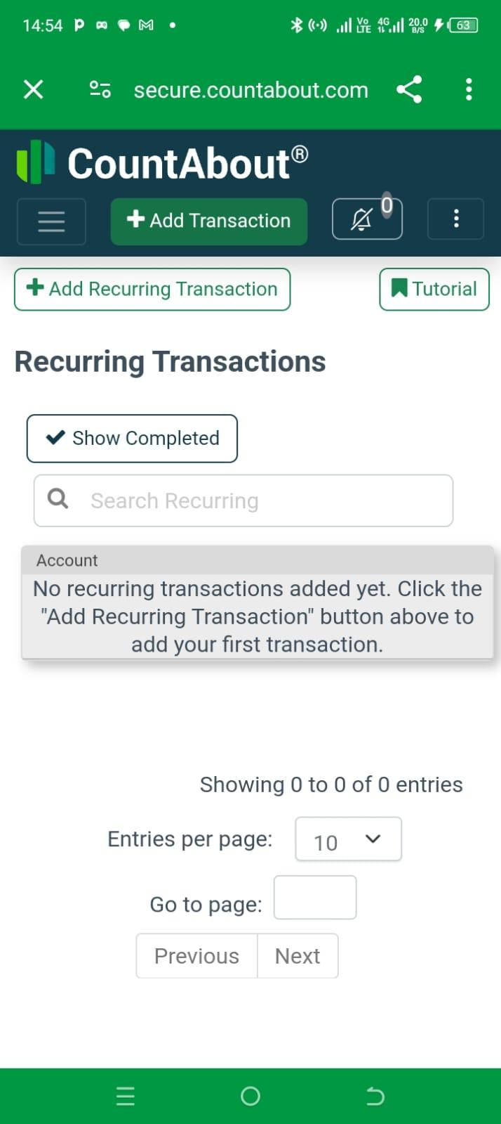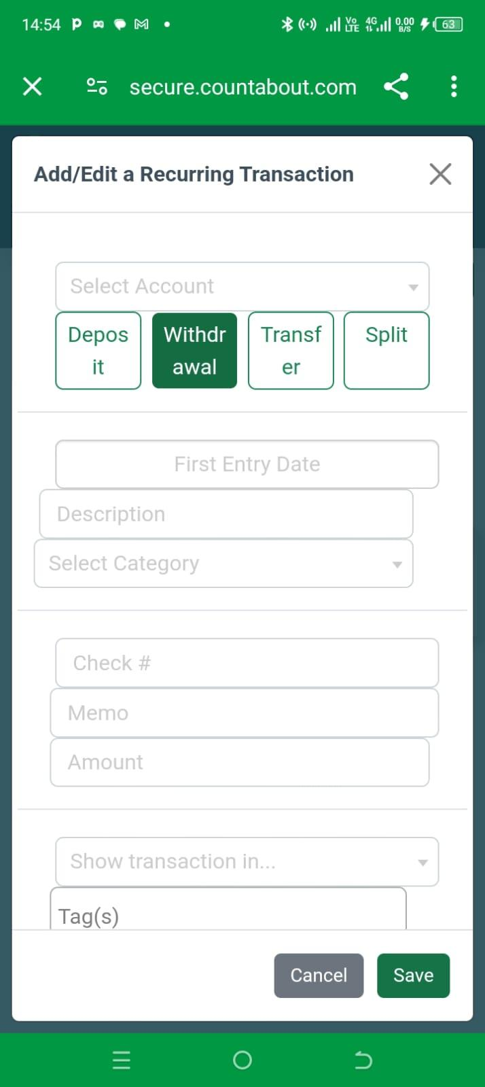

### Recurring Transactions

Manages regular payments by automating the recording of repeat transactions (e.g., rent, subscriptions) at set intervals, saving time and ensuring accuracy.

### Adding Transactions

Allows users to manually input income or expenses, categorize them, and specify details like amount, date, and payment method for accurate tracking.

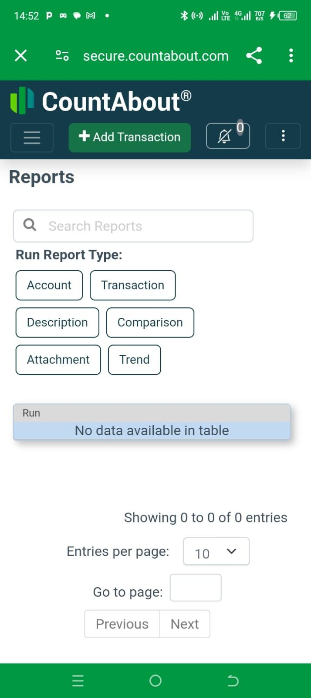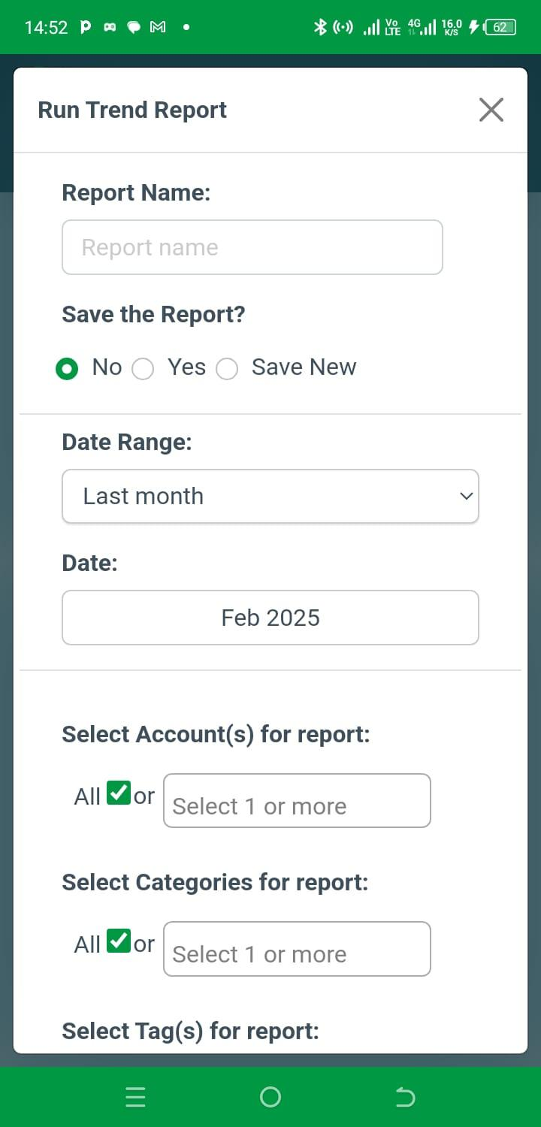

### Reports Section

Generates detailed financial reports over selected periods, breaking down income, expenses, and net worth, helping track progress and identify spending patterns.

**Strengths and Weaknesses**

Strengths

* Integration with Platforms: CountAbout excels in importing data from various platforms like Mint and Quicken, making data migration seamless and eliminating manual entry.
* Ad-Free Environment: It provides a clean, distraction-free experience for managing finances.
* Affordable Pricing: The basic version costs just R190 per year, and the premium version offers additional features at R760 per year.

### Weaknesses

* Mobile App Limitations: The mobile version lacks some essential features found in the web version, making it harder to manage finances on the go.
* Lack of Gamification: It doesn’t include engaging features like rewards or progress tracking, which may reduce motivation for some users.
* Limited Advanced Features: CountAbout lacks AI-driven insights or advanced analytics, which could enhance user experience for those seeking deeper financial analysis.

**Key Features of CountAbout**

* Data Importing: Seamlessly imports financial data from platforms like Mint, Quicken, and CSV files.  
  Multi-Currency Support: Track finances in different currencies, ideal for international users or travelers.
* Recurring Transactions: Automates the tracking of recurring payments such as rent, subscriptions, and bills.
* Customizable Categories and Tags: Users can create personalized categories and tags to organize their transactions more efficiently.
* Budgeting Tools: Set up budgets, track expenses, and monitor financial goals to stay on top of spending.
* Financial Reports: Generate detailed reports and insights on income, expenses, and budget progress.

App 3:YNAB (You Need A Budget)

YNAB is a budgeting app that helps users allocate every rand of income, track goals, and sync finances across devices to manage money, eliminate debt, and save for the future.

**Overview of the app**

Onboarding and personalization

When users first open YNAB, they answer questions about their financial situation, such as income, expenses, and budgeting experience. This helps the app personalize the experience and guide new users based on their specific needs, ensuring a tailored approach to budgeting.

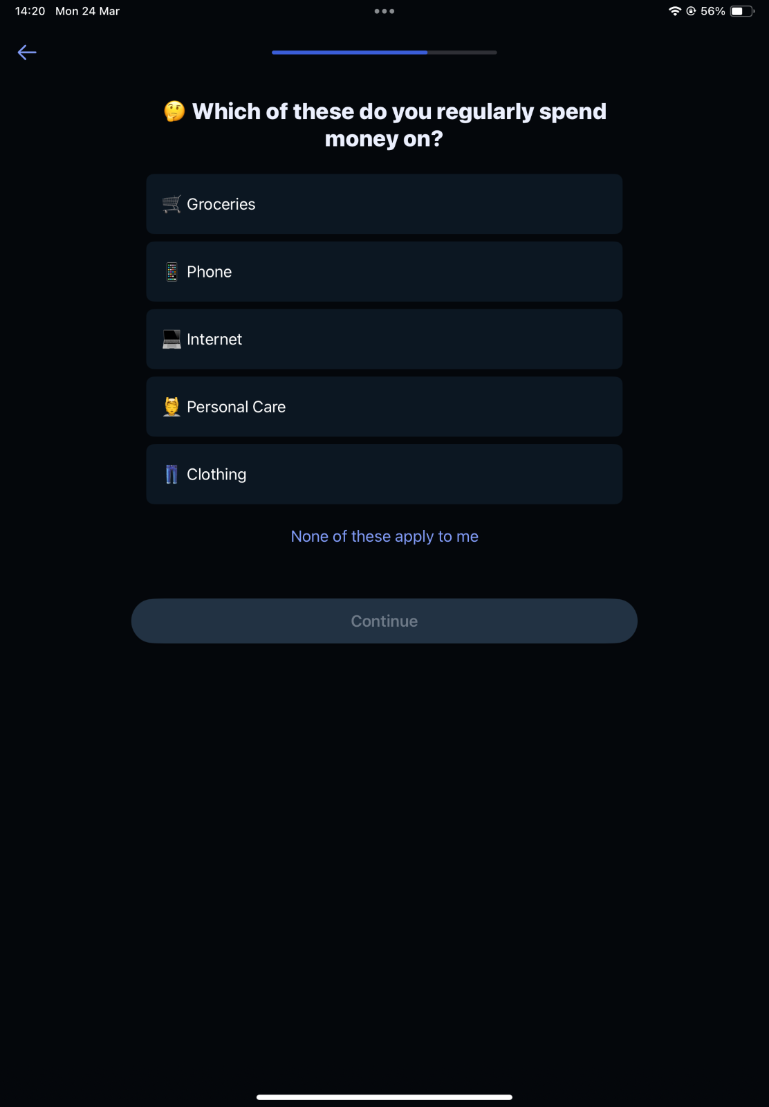

Zero-Based Budgeting

YNAB's core feature is its zero-based budgeting system, where users allocate every rand to a specific category, such as bills, savings, or entertainment. This method ensures that no money is left unassigned, and users can set priorities, such as focusing on debt repayment or saving for an emergency fund.

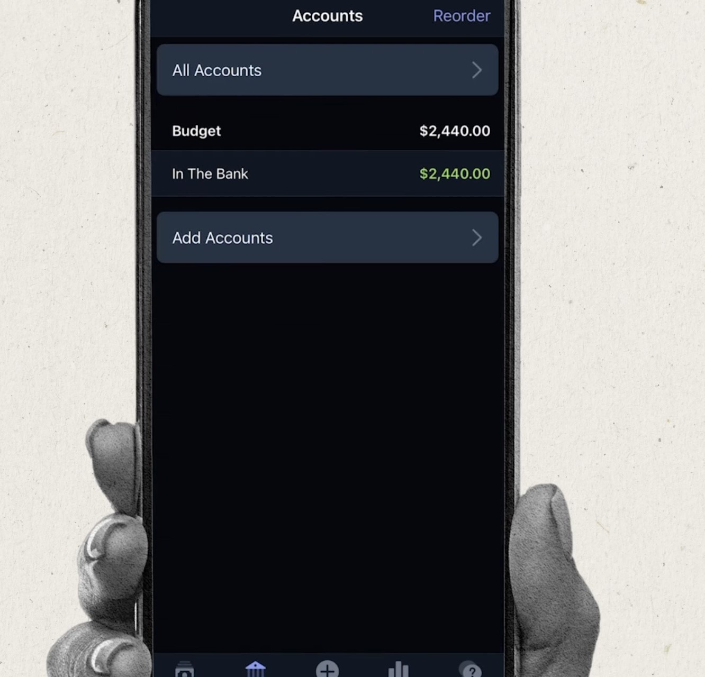

Goal Tracking and Savings Planner

YNAB allows users to set specific financial goals, like saving for a vacation or paying off debt, and tracks their progress with clear visual indicators. It also offers personalized recommendations on how much to contribute monthly to meet goals within a set time frame.

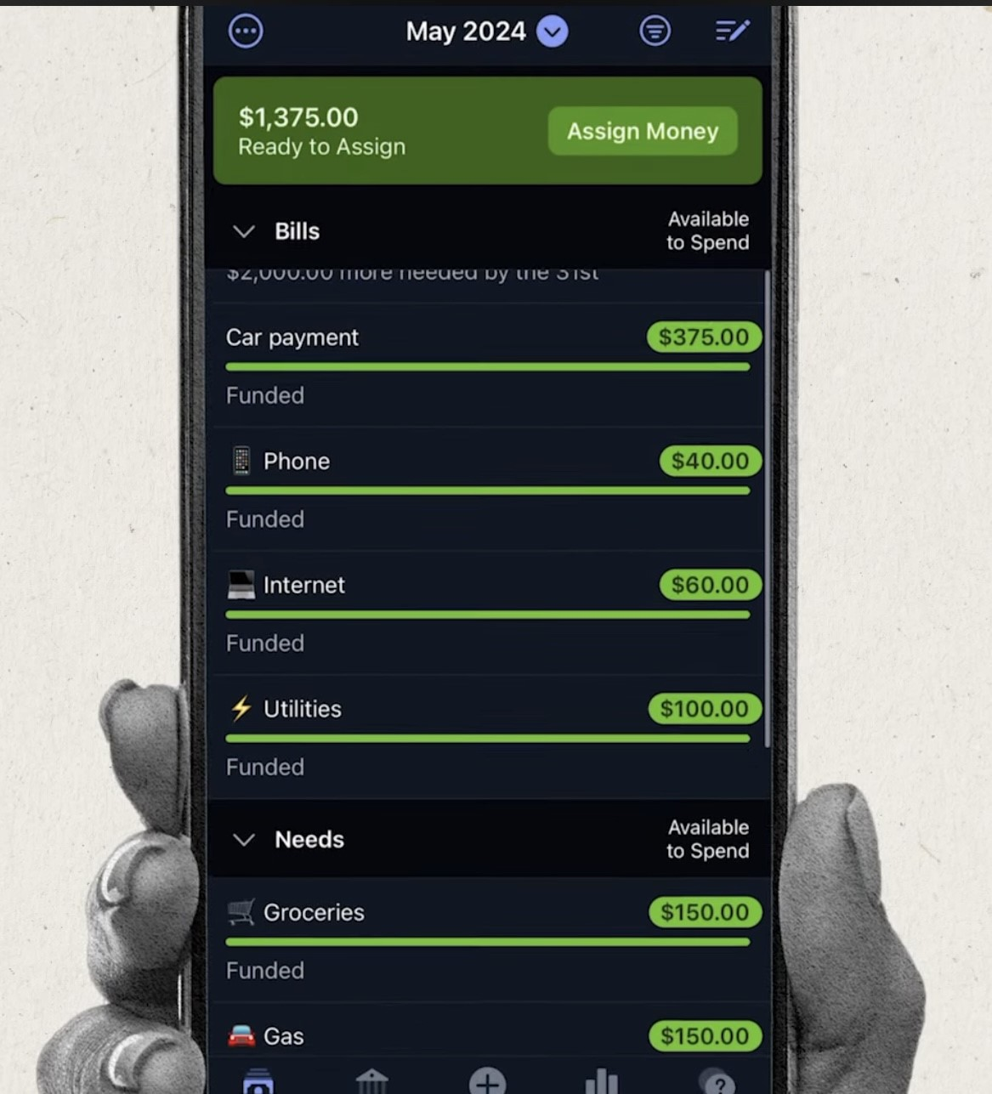

Financial Reports & Insights

YNAB generates various financial reports that offer valuable insights into users’ financial health. These include spending reports, net worth tracking (showing total assets minus liabilities), and income vs. expense charts, which help users identify trends, monitor their progress, and make informed decisions.

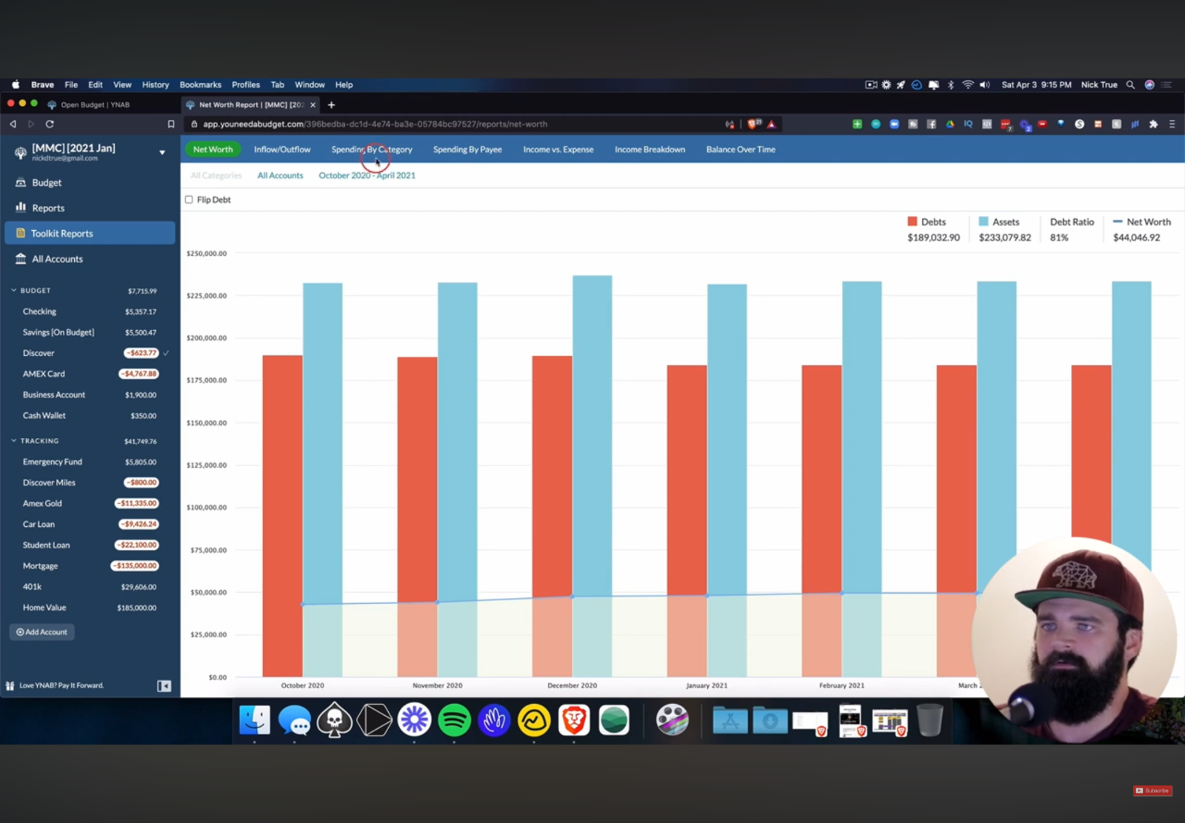

Manual Transaction Entry & Bank Syncing

YNAB allows users to manually enter transactions or import bank statements in CSV format. This ensures that users can keep their budget updated, even if automatic syncing with local banks is not available. Transactions are categorized to maintain an accurate budget at all times.

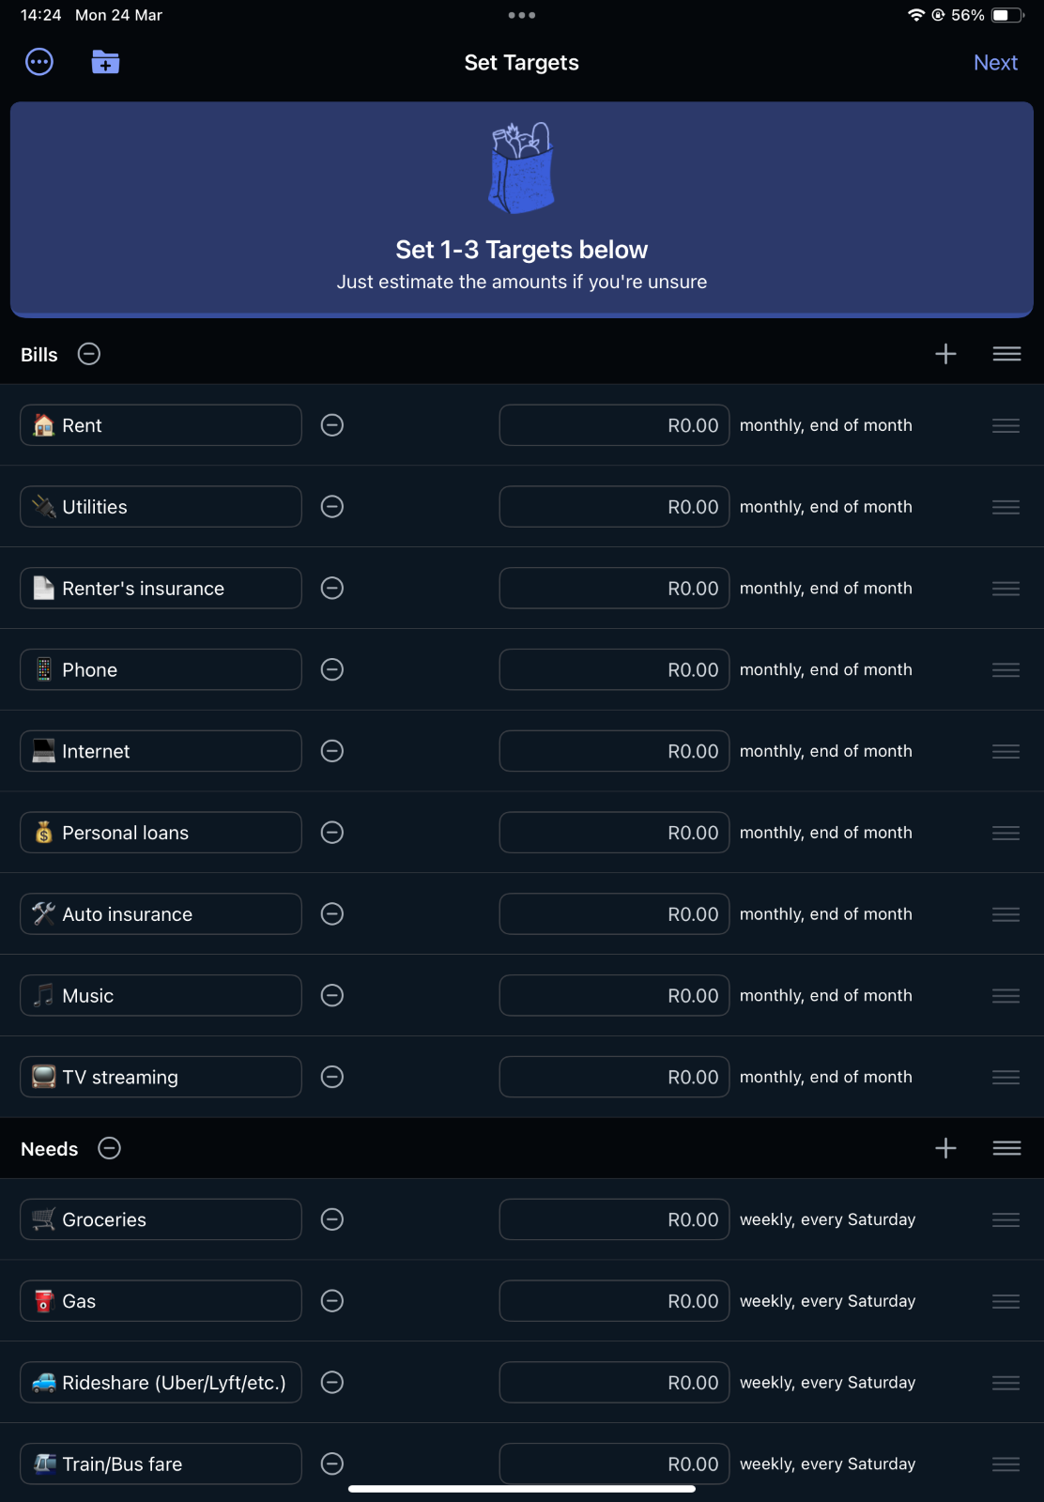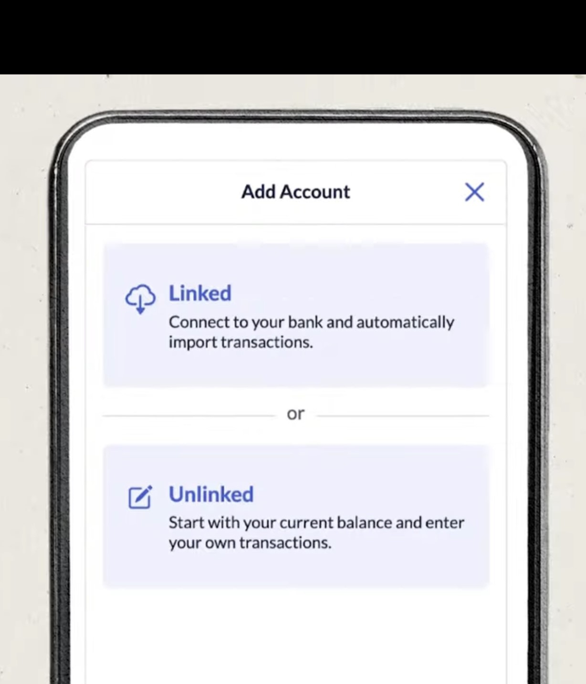

YNAB Assistant

The app features an integrated chatbot that provides automated assistance, helping users navigate budgeting tools, answer questions, and offer financial insights. The bot can suggest ways to allocate funds, remind users about upcoming expenses, and provide quick answers to budgeting queries.

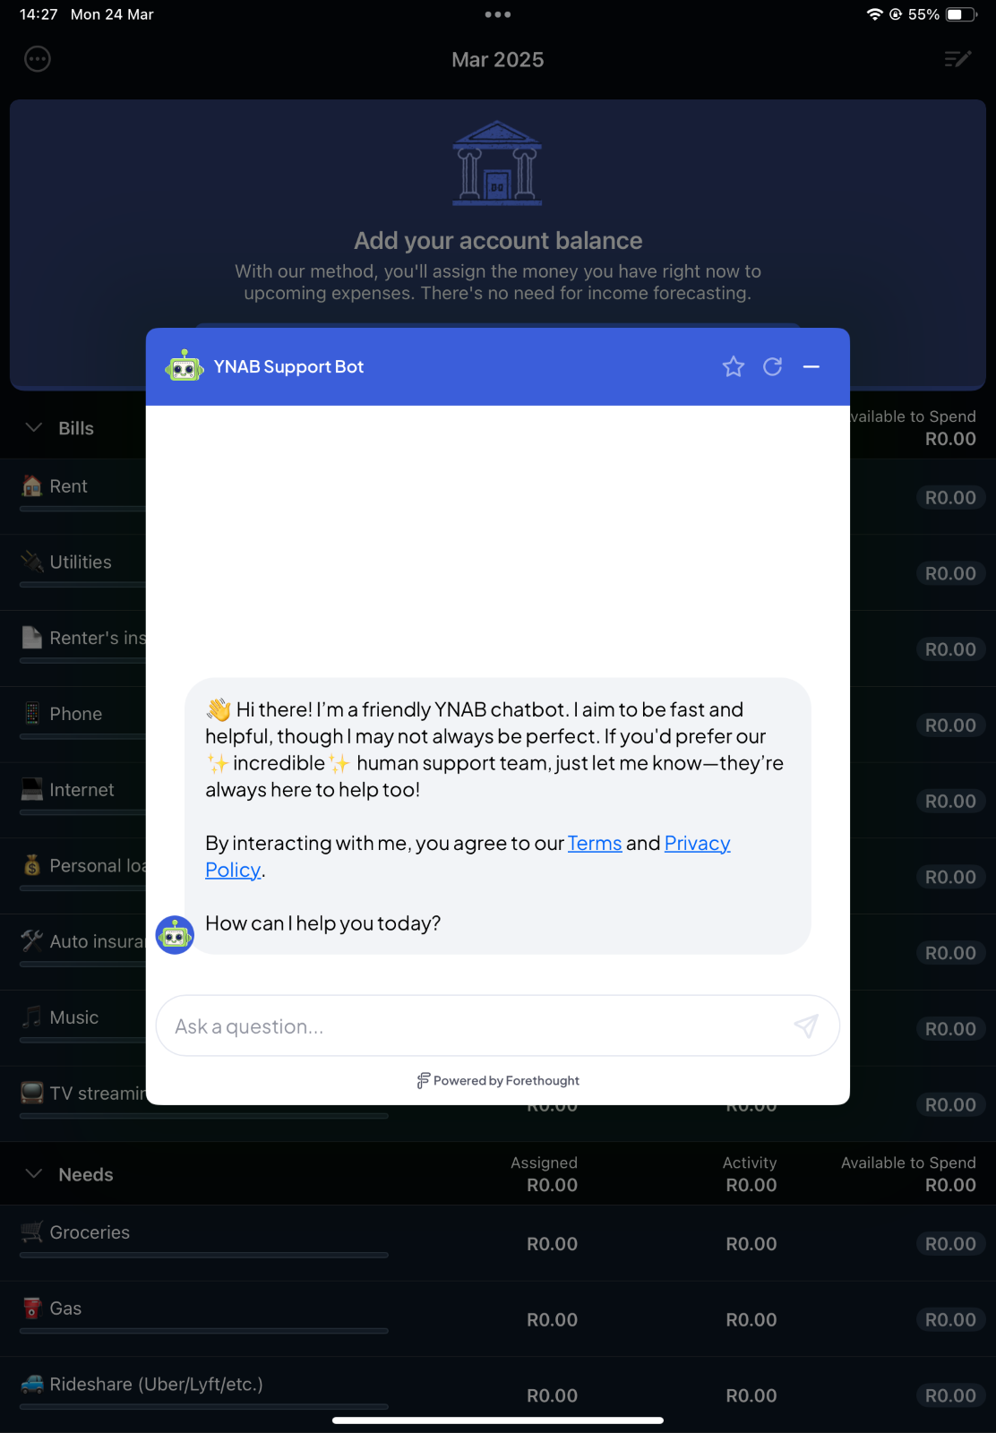

**Strengths of YNAB**

* Zero-Based Budgeting – Ensures every rand has a purpose, making budgeting more effective.
* Goal Tracking – Helps users set and track savings or debt payoff goals.
* Real-Time Syncing – Updates budgets instantly across multiple devices.
* Financial Reports – Provides clear insights into spending, income, and net worth.

**Weaknesses of YNAB**

* Subscription Cost – Requires a paid subscription after the free trial.
* Manual Bank Imports – No automatic bank syncing for South African users; transactions must be entered manually or uploaded via CSV.
* Learning Curve – The zero-based budgeting method may take time to understand, especially for beginners.
* No Investment Tracking – Doesn’t support tracking of stocks or other investments.

**Key Features of YNAB**

* Zero-Based Budgeting System – Unlike traditional budgeting apps, YNAB follows a unique method where every rand is assigned a job, ensuring full control over finances.
* Rule-Based Money Management – YNAB teaches four simple rules to help users manage their money effectively: Give Every Rand a Job, Embrace Your True Expenses, Roll with the Punches, and Age Your Money.
* Goal-Based Budgeting – Users can set specific savings or debt repayment goals, and YNAB provides recommendations on how much to allocate each month to reach them.
* Real-Time Syncing – The app syncs budgets instantly across multiple devices, making it easy for users to track finances on the go.
* Spending and Net Worth Reports – Provides clear, visual reports that help users analyze spending trends, track net worth, and adjust financial plans.
* Debt Payoff Planner – Helps users prioritize debt repayment by creating a structured plan and tracking progress

**Visual Infographic comparison of all the app**

|  |  |  |  |
| --- | --- | --- | --- |
| **Criteria** | **YNAB** | **Count About** | **Firefly III** |
| Cost | $14.99/month or $109/year, 34-day free trial | Free with premium starting at $9.99/year | Free (self-hosting costs may apply) |
| Ease of Use | 4.8/5 (App Store, Google Play) | 4/5 | 3/5 (requires technical setup) |
| Budgeting Features | Zero-based budgeting, Goal tracking | Custom categories, Automatic transaction syncing | Expense tracking, Financial reporting |
| Bank Integration | Yes (automatic syncing) | Yes (automatic downloads) | Yes (manual setup for self-hosting) |
| Expense Tracking | Yes (detailed categories) | Yes (with customizable tags) | Yes (customizable categories) |
| Reports & Insights | Yes (reports on spending and savings) | No detailed reports | Yes (financial reporting and charts) |
| Mobile App Support | Yes (iOS & Android) | Yes (iOS & Android) | No official app (self-hosting) |
| Security | High (encryption, multi-factor authentication) | Moderate | Moderate (self-hosted, user-managed security) |
| User Ratings | 4.8/5 | 4/5 | N/A |
| Pros | Comprehensive budgeting, high user ratings | Affordable, flexible categories | Free, highly customizable |
| Cons | High cost, learning curve | Limited features compared to competitors | Requires technical knowledge for self-hosting |

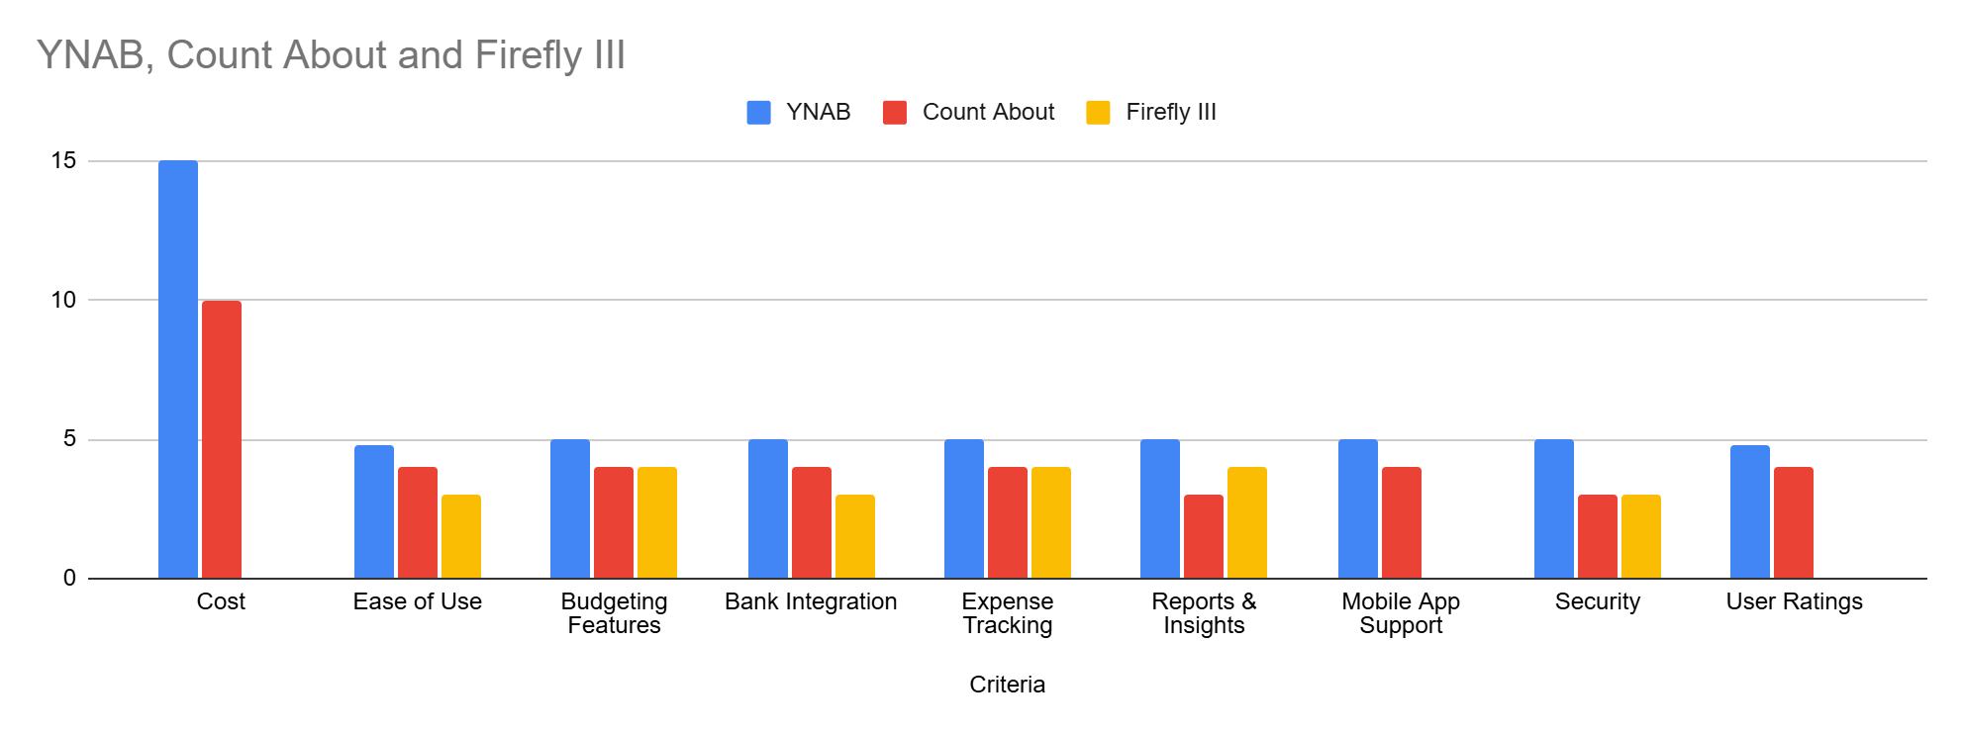

**Best features in the apps that will be implemented on the app( Budget Master)**

* Transaction History (from Count About): Lets users view and edit past transactions for better record-keeping.
* Recurring Payments (from YNAB and Count About): Automates adding regular payments like subscriptions or rent, saving users time and effort.
* Bill Reminders (from YNAB): Notifies users of due dates for recurring payments to ensure they never miss a payment.
* Savings Goal (from YNAB): Helps users set and track specific financial goals, such as saving for a vacation.
* Currency Support (from Firefly III): Allows users to track their budget in different currencies.Ideal for international users or those who travel frequently.
* Simple Reports (from Firefly III): Generate simple visual reports, such as pie charts or bar graphs, to compare spending against the budget.

**Conclusion**

This research has helped me understand how to design my budgeting app in a way that is simple and useful for users. By looking at YNAB, Count About, and Firefly III, I learned which features make budgeting easier, like tracking expenses, setting savings goals, and managing spending. It also showed me the importance of automation, reports, and syncing across devices. With this knowledge, I can structure my app to be user-friendly, helping people manage their money more effectively.

References

Firefly III. (n.d.). Personal finance manager screenshots, [Online] Available at: [https://firefly-iii.org](https://firefly-iii.org/) [Accessed 26 March 2025].

Forbes Advisor. (2025). *YNAB Budgeting App Review 2025*. Retrieved March 25, 2025, from<https://www.forbes.com/advisor/banking/ynab-budgeting-app-review/> [Forbes](https://www.forbes.com/advisor/banking/ynab-budgeting-app-review/?utm_source=chatgpt.com)

NerdWallet. (2025). *Review: We Tested the YNAB App*. Retrieved March 25, 2025, from<https://www.nerdwallet.com/article/finance/ynab-app-review> [NerdWallet: Finance smarter](https://www.nerdwallet.com/article/finance/ynab-app-review?utm_source=chatgpt.com)

CNET. (2025). *YNAB Review 2025: Best Budgeting App for Detailed Money Management*. Retrieved March 25, 2025, from<https://www.cnet.com/personal-finance/banking/ynab/> [CNET](https://www.cnet.com/personal-finance/banking/ynab/?utm_source=chatgpt.com)

The Africa Logistics. (2025). *In-Depth Review of YNAB (You Need A Budget) App*. Retrieved March 25, 2025, from<https://theafricalogistics.com/in-depth-review-of-ynab-you-need-a-budget-app/> [The Africa Logistics](https://theafricalogistics.com/in-depth-review-of-ynab-you-need-a-budget-app/?utm_source=chatgpt.com)

Millennial Money. (2025). *You Need a Budget Review 2025 | The Truth About YNAB*. Retrieved March 25, 2025, from<https://millennialmoney.com/ynab-review/> [Millennial Money](https://millennialmoney.com/ynab-review/?utm_source=chatgpt.com)

Anon. 2025. *CountAbout | Be in control of your finances*. [online] CountAbout. Available at: <<https://countabout.com/>> [Accessed 28 March 2025].